Sister Joan Chittister, O.S.B. points out a flaw in the 'pro-life' movement:
Sister Joan is a social psychologist, who leads a worldwide network of women for peace and runs a spiritual Web site. She has a Ph.D., 11 honorary degrees and was the recipient of the Distinguished Alumni Award from Penn State. She is the author of 30 books, including Called to Question: a Spiritual Memoir, Scarred by Struggle; Transformed by Hope.
Thank you, Sister Joan, for saying this.
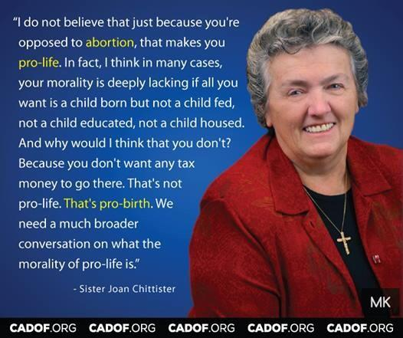
Isn’t birth as sacred as the initiation of the fetus? Isn’t the development of a baby learning to relate to his/her loved ones, and to say words describing his/her environment as sacred as the growth of a fetus? Isn’t motherhood and fatherhood a sacred time in life, especially when parent(s) are secure and earning a living wage?
Many Right-to-Lifers have no concern for the lives they are bringing into the world. Do they know when a man and a woman are ready for parenthood. Do they care for the births that are responsible for.
My doctor husband, now deceased, often saw women in the emergency ward who self aborted their pregnancies rather than give birth to an unwanted child. It is an ugly death for mother and fetus. These women cared about childbirth and raising a child. They were not ready. They gave their lives for their values. Those of you defunding Planned Parenthood, please think of these very sad deaths and the values of the mothers enduring this suffering.
I volunteer at an urban summer literacy program, having given several references and an annual CORY clearance. I fell in love with one lively 5 year-old child who responded well to affection and attention. After class I saw her pleading for lunch, which her foster Mom failed to send. I so wanted to help her, but I am 80 years old – too old to adopt a young child.
The children in this literacy program certainly qualified for the federally funded summer meals program. But the meals program is way under-funded by many in our government and those who elect them. They believe in the right to life, or is it the right to hunger and homelessness and despair?

